- Unless there's a major turnaround in the next four weeks, the Labour party will win July's UK general election with a very large majority. In the early stages of the election campaign, neither of the main parties have been candid about the poor fiscal situation the next government will inherit, and we doubt this will change when they publish their manifestos next week.
- The S&P Global surveys for May reported contrasting sectoral fortunes, with manufacturing and construction activity accelerating, but the pace of services growth cooling from April's very strong rate. The data are consistent with our view that while the recovery is becoming more firmly entrenched, q/q GDP growth is likely to be slower in Q2 than it was in Q1.
With four weeks to go until polling day, the general election campaign is in full swing. So far, the opinion polls suggest the campaign has done little to reduce the likelihood that the Labour party will form the next government – the only uncertainty appears to be around the margin of their victory.
On June 6, the Financial Times' poll tracker showed Labour on 44%, well ahead of the Conservatives on 24%. Translating the poll results into parliamentary seats is always challenging given that support for parties tends to be uneven across the country. Multilevel regression and post-stratification (MRP) models combine opinion polls with demographic information to produce seat-by-seat forecasts, so tend to be the most robust method for predicting the election result. Three MRPs were published this week, and on average they predicted that Labour would win 430 of the 650 parliamentary seats, giving them a majority of 211 (Chart 1). As reference points, the Conservatives won a majority of 80 seats in 2019, while Tony Blair's first victory for Labour in 1997 yielded a majority of 179.
This week's televised leaders debate triggered a row around the veracity of costings of Labour's tax policies. But that just distracted from the elephant in the room, namely that both main parties are guilty of a lack of candour about the severity of the fiscal situation. Both promise to comply with the fiscal rules without increasing any of the main taxes, while also spending more than is currently planned on public services.
Chart 1: The Labour party is on track to secure a large majority in next month's general election
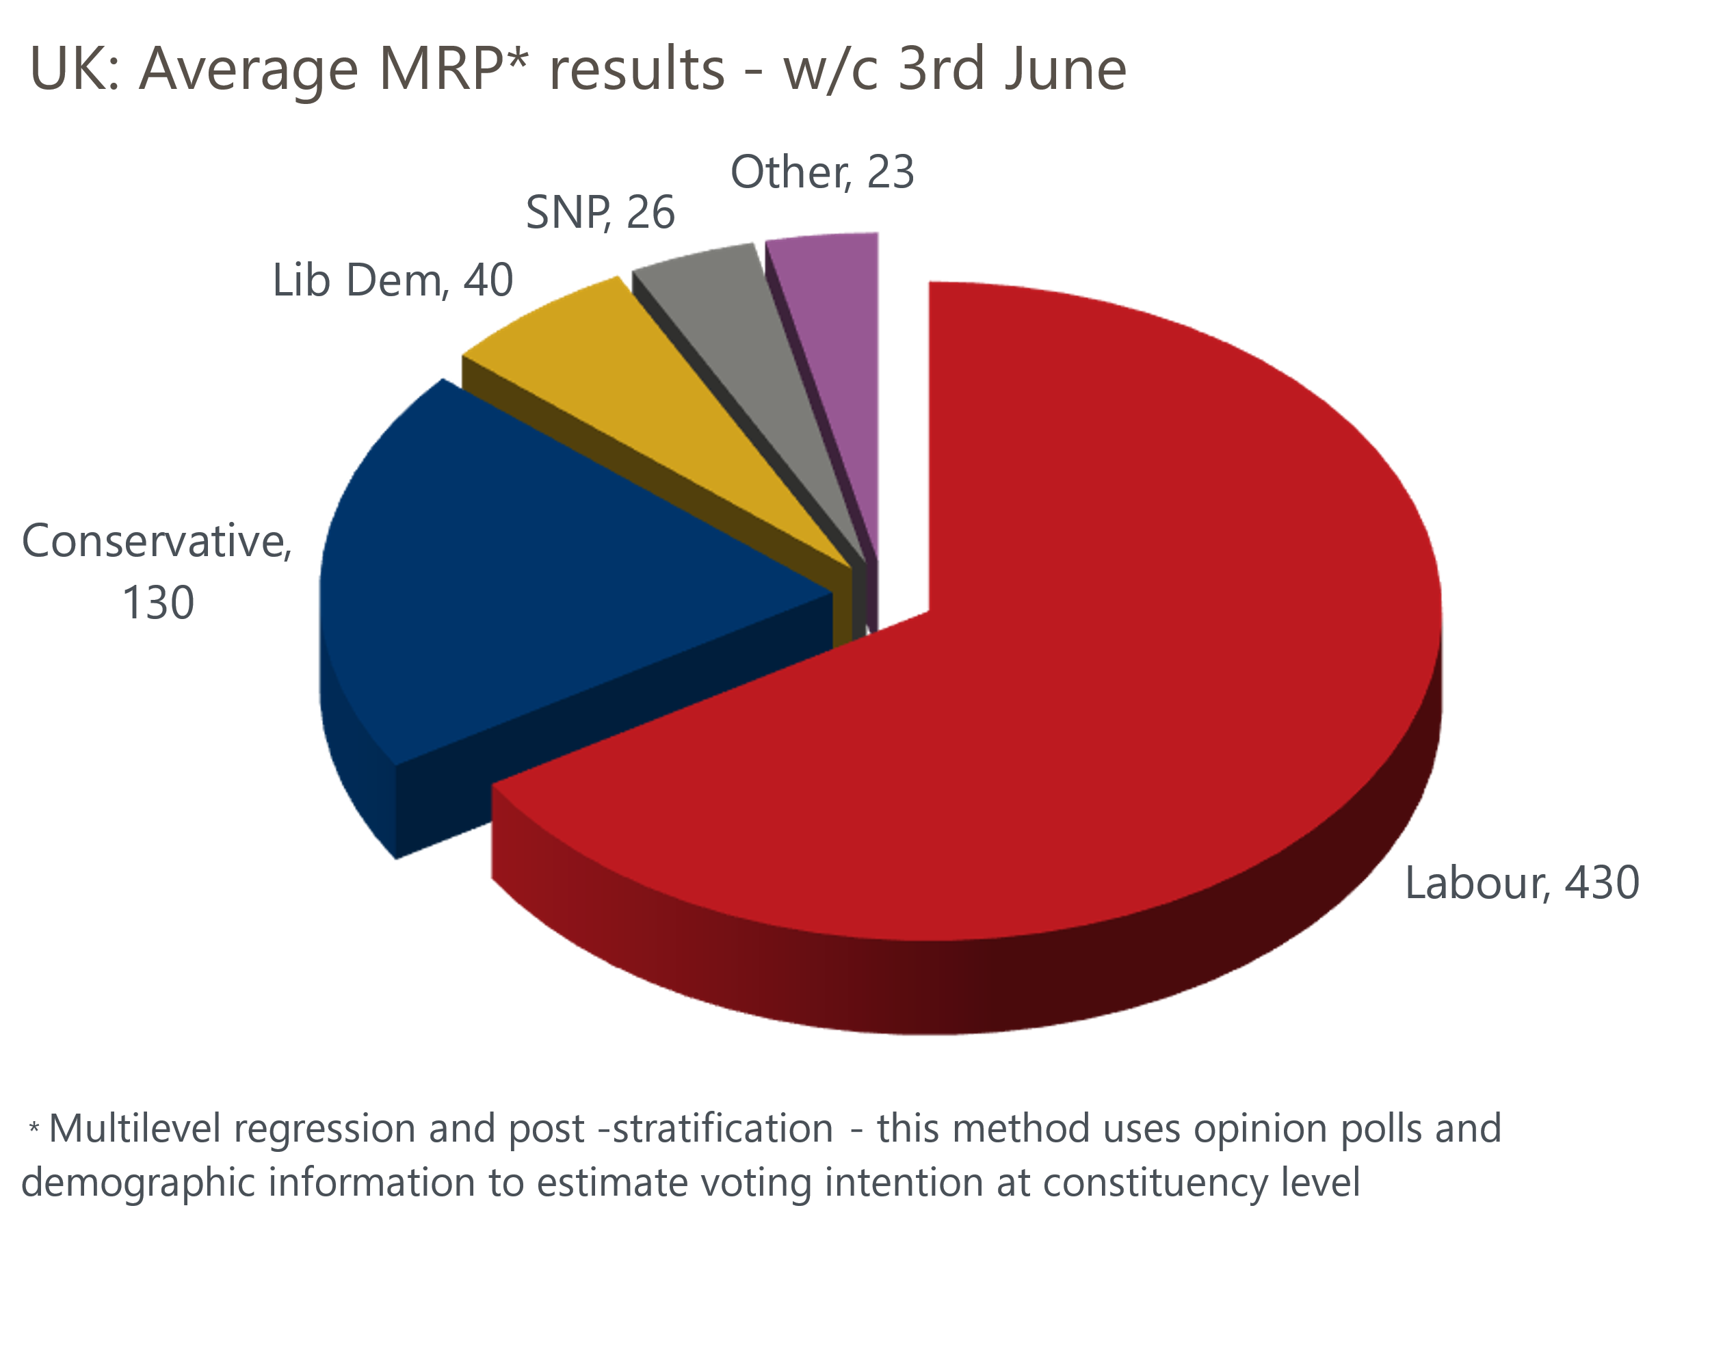
Source: Oxford Economics calculations using data from More In Common, YouGov, and Survation

These three promises are inconsistent with one another. It's possible that the party's manifestos – rumoured to be published next week – will provide a more candid assessment and plans to rectify the situation. But we think that's unlikely – voters rarely reward parties for such honesty. So while we plan to run the manifestos through our Global Economic Model to assess their potential impact on the economy, we suspect that whoever wins the election will adopt a different approach to fiscal policy when they assume power.
It's been a relatively quiet week for economic data. The final S&P Global surveys for May largely confirmed the picture painted by the flash surveys published a couple of weeks ago. Manufacturing activity returned to positive territory, after April's dip, with the PMI reaching a 22-month high. But we'd be hesitant to suggest that this upturn is likely to be mirrored in the official output series because there's been virtually no relationship between the ONS data and the S&P Global survey over the past year. While the S&P Global survey suggests that the sector is finally emerging from a prolonged recession, manufacturing has been enjoying boom conditions according to the official output data.
The construction survey also offered reason for encouragement, with the PMI reaching a two-year high. That indicator has tended to track the official output series much more closely than its manufacturing counterpart, suggesting we should see a strong rebound in construction output in Q2, after activity in Q1 had been hampered by a prolonged period of wet weather.
On the services side, May's final S&P Global survey reported a marked slowdown in the pace of activity growth, though a PMI of 52.9 was still some way above the average of the past couple of years. The pickup in manufacturing output meant that the drop in the composite PMI was smaller, to 53.0 from 54.1 in April. This still implies a decent pace of GDP growth in Q2 (Chart 2). But there's likely to be a drag from sectors not covered by the PMIs given April's poor retail sales outturn and the planned strikes by junior doctors at the end of this month. So q/q growth in Q2 is likely to be softer, following Q1's strong expansion.
Chart 2: The PMIs imply a decent pace of GDP growth in Q2, but other sectors are likely to drag
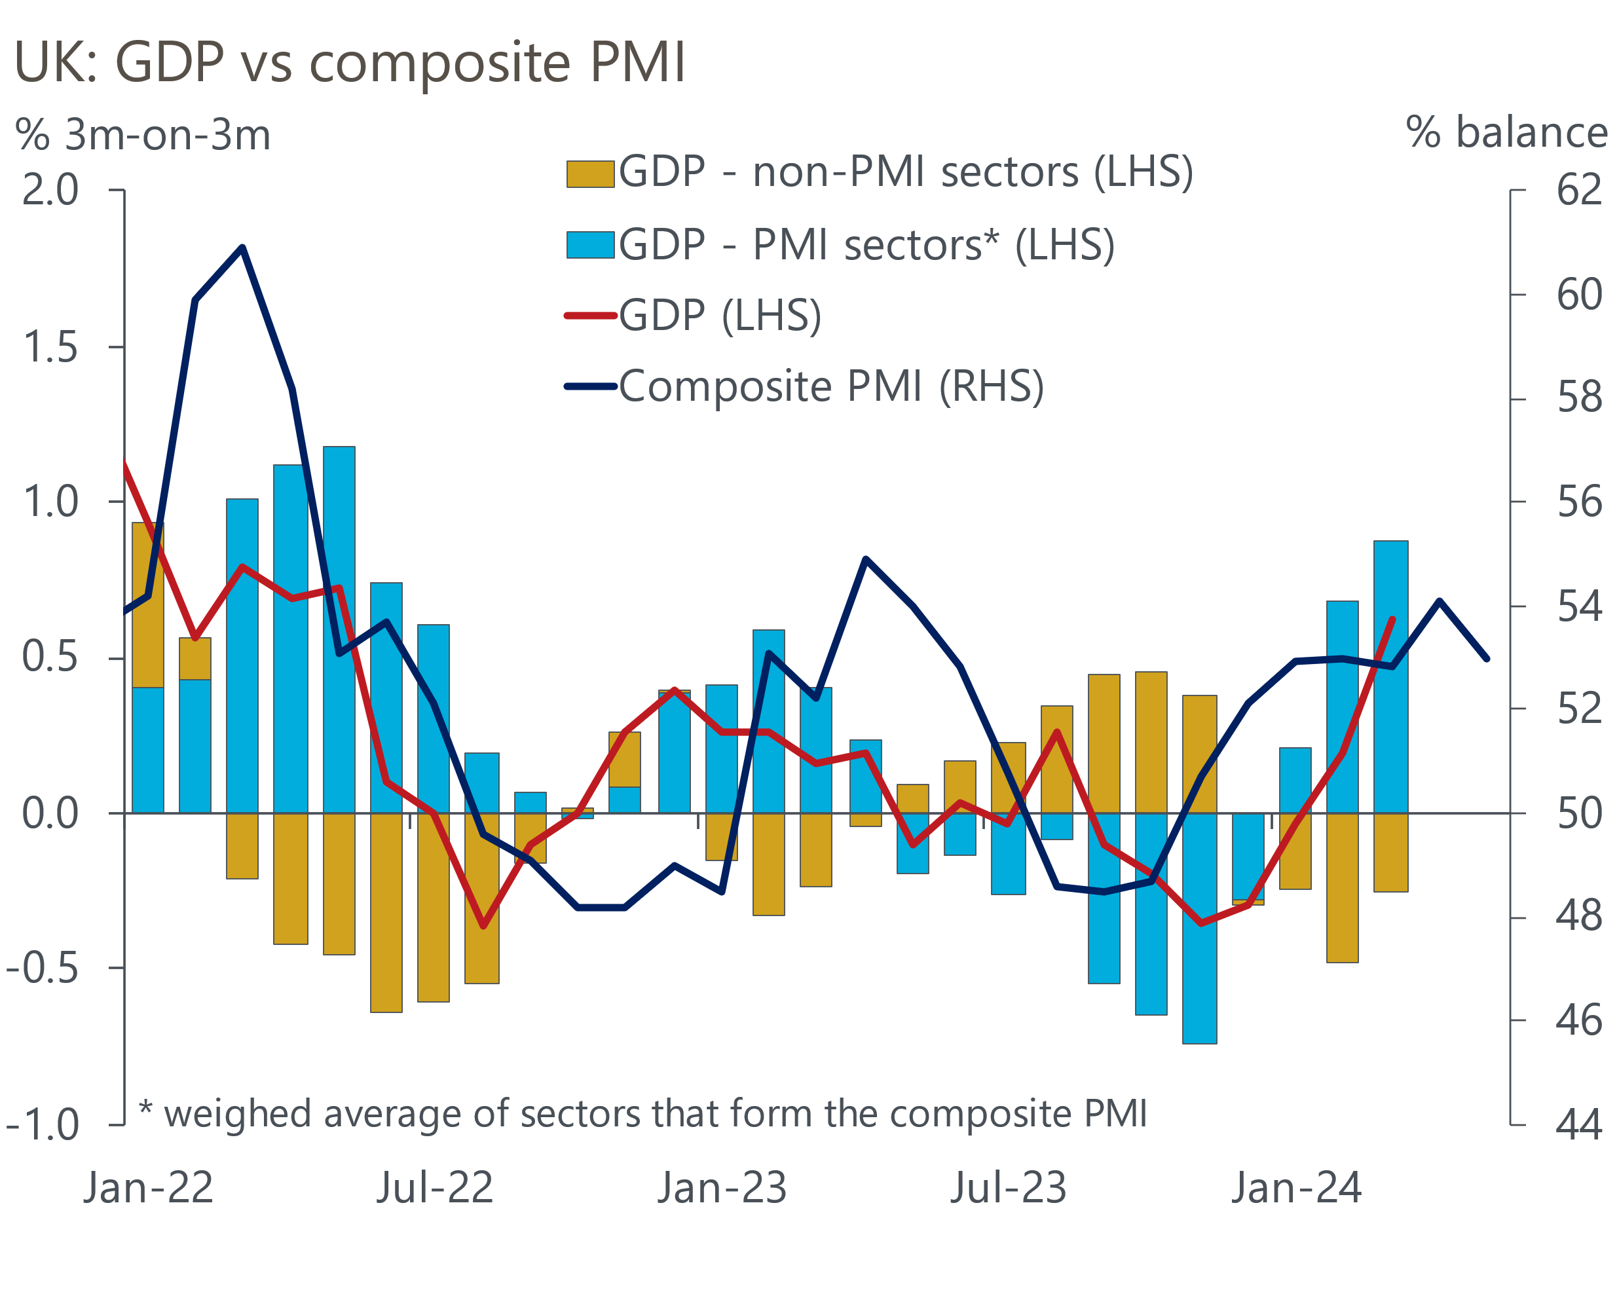
Sources: Oxford Economics, ONS, S&P Global
The S&P Global surveys offered good news on the inflation front. In particular, input costs rose at the slowest pace in three years in the services sector, after April's national living wage-related surge, and there was also a further slowdown in prices charged inflation. The Bank of England's Decision Maker Panel for May also reported cooling price pressures and – crucially in terms of the monetary policy outlook – firms' expectations for future wage growth continued to drop.
Though April's upside surprise for services inflation has taken a June rate cut off the table, we still expect the Monetary Policy Committee to move later in the summer, provided incoming data is supportive. Seeing the official pay series follow the more benign trend of the DMP will be a crucial piece of the jigsaw for the MPC. So next week's pay data for April, which will include the impact of the large national living wage rise, is likely to be particularly important.

The week ahead
Tuesday's labour market release will include the pivotal April data for pay growth. The national living wage rose by nearly 10% that month and as well as the direct impact, there's likely to be upward pressure on pay in roles that pay a premium over the NLW. However, we think the impact is likely to be spread over several months, rather than being focused solely on April, which likely explains the recent strength in pay growth. And headline (three-month average of the annual rate) earnings growth will be dampened by strong base effects caused by large increases in pay in April 2023. So we expect the main measures of pay growth to rise by just 0.1ppts between March and April, with headline total pay growth at 5.8% and regular pay growth at 6.1% in April.
The ONS is still in the process of implementing changes that it hopes will increase Labour Force Survey sample sizes and reduce volatility, so there's still much uncertainty around the likely path of the LFS series. Most other indicators suggest labour demand is cooling gently, and we think the ONS will report that unemployment was 4.3% in the February to April period.
March saw a big upside surprise for GDP on the back of strong outturns for consumer-facing services and health. We expect some payback in April. Retail sales fell sharply that month, while we suspect some of March's strength in other sectors might be due to the early Easter. But these downward pressures should be mitigated by a rebound in construction output, after February and March were disrupted by a long period of very wet weather. On balance, we expect GDP to have fallen 0.3% m/m in April.
Table 1: Week ahead calendar
Date | Events | Period | Measure | Unit | Previous | Forecast
Jun 11 | LFS unemployment | Feb-Apr | Rate | % | 4.3 | 4.3
Jun 11 | Average earnings (total pay) | Apr | 3m, y/y | % | 5.7 | 5.8
Jun 11 | Average earnings (regular pay) | Apr | 3m, y/y | % | 6.0 | 6.1
Jun 12 | GDP | Apr | m/m | % | 0.4 | -0.3
Jun 12 | GDP | Apr | 3m/3m | % | 0.6 | 0.6
Jun 12 | Index of services | Apr | m/m | % | 0.5 | -0.4
Jun 12 | Index of services | Apr | 3m/3m | % | 0.7 | 0.7
Jun 12 | Manufacturing output | Apr | m/m | % | 0.3 | -0.6
Jun 12 | Manufacturing output | Apr | y/y | % | 2.3 | 1.2
Jun 12 | Industrial production | Apr | m/m | % | 0.2 | -0.3
Jun 12 | Industrial production | Apr | y/y | % | 0.5 | 0.1
Jun 12 | Construction output | Apr | m/m | % | -0.4 | 1.0
Jun 12 | Construction output | Apr | y/y | % | -2.2 | -0.9
Jun 12 | UK trade | Apr | Trade balance | £bn | -1.1 | -1.5
Jun 12 | UK trade | Apr | Visible balance | £bn | -14.0 | -14.2
Source: Oxford Economics

Key forecasts
Table 2: UK forecast overview
(Annual percentage changes unless specified)
 | 2022 | 2023 | 2024 | 2025 | 2026 | 2027
GDP | 4.3 | 0.1 | 0.9 | 2.0 | 1.9 | 1.6
Private consumption | 4.8 | 0.2 | 0.7 | 2.6 | 2.2 | 1.6
Fixed investment | 8.0 | 2.2 | -0.5 | 0.8 | 2.7 | 2.1
Government consumption | 2.3 | 0.5 | 3.4 | 2.8 | 1.6 | 1.5
Exports of goods and services | 9.0 | -0.5 | -0.9 | 2.7 | 2.3 | 1.7
Imports of goods and services | 14.6 | -1.5 | 0.2 | 4.7 | 2.9 | 1.9
Industrial Production | -3.5 | -0.4 | 0.3 | 0.9 | 1.5 | 1.1
Consumer prices | 9.1 | 7.3 | 2.5 | 2.5 | 2.3 | 2.2
Unemployment rate (%) | 3.9 | 4.0 | 4.3 | 4.0 | 3.8 | 3.8
Current a/c balance (% of GDP) | -3.1 | -3.3 | -2.7 | -3.2 | -3.2 | -3.1
Government balance (% of GDP) | 4.4 | 5.0 | 3.7 | 3.2 | 2.4 | 1.5
Cen. bank policy rate (%, EOP) | 3.50 | 5.25 | 4.75 | 3.75 | 2.75 | 2.00
10yr govt. bond yield (%, EOP) | 3.67 | 3.54 | 4.05 | 3.68 | 3.20 | 2.85
Exchange rate (US$ per £, EOP) | 1.20 | 1.27 | 1.26 | 1.27 | 1.30 | 1.32
Exchange rate (euro per £, EOP) | 1.13 | 1.15 | 1.17 | 1.17 | 1.17 | 1.16
Source: Oxford Economics
Table 3: Quarterly forecasts for the UK
 | 2024 |  |  |  | 2025
 | Q1 | Q2 | Q3 | Q4 | Q1 | Q2 | Q3 | Q4
GDP (% year) | 0.2 | 0.4 | 1.0 | 1.8 | 1.7 | 2.1 | 2.2 | 2.2
CPI inflation (% year) | 3.5 | 2.1 | 2.0 | 2.5 | 2.5 | 2.3 | 2.6 | 2.4
Bank Rate (%, EOP) | 5.25 | 5.25 | 5.00 | 4.75 | 4.50 | 4.25 | 4.00 | 3.75
10yr gilt yield (%, EOP) | 3.95 | 4.25 | 4.11 | 4.05 | 3.97 | 3.89 | 3.79 | 3.68
US$ per £ (EOP) | 1.26 | 1.26 | 1.26 | 1.26 | 1.26 | 1.26 | 1.27 | 1.27
Euro per £ (EOP) | 1.17 | 1.17 | 1.17 | 1.17 | 1.17 | 1.17 | 1.17 | 1.17
Source: Oxford Economics

Latest Country Economic Forecast:
May 15, 2024

Recent publications

Data Insights
Weaker services PMI points to less robust activity growth in Q2
Manufacturing PMI jumped to a 22-month high in May
Costlier deals halted the recovery in mortgage approvals
Sharp fall in retail sales points to softer GDP growth in Q2
Composite PMI falls, but recovery still running at a solid pace

Research Briefings
Will the BoE slow QT?
Why the neutral interest rate will stay structurally low
Why the BoE can and will cut before the Fed
How quickly are indirect effects on core inflation fading?
Dovish MPC signals a summer rate cut is likely

Contacts

Oxford Economics' UK team
- Andrew Goodwin - Chief UK Economist - agoodwin@oxfordeconomics.com
- Edward Allenby - UK Economist - eallenby@oxfordeconomics.com

